# ASSIGNMENT 3

**A simple RESTFUL API using React.js, Database Creation, and Creating Index**

**NAME:singareddy navya**

**E-mail:** navyareddysingareddy17@gmail.com

**Phone No :** 9390397153

**College :** Loyola institute of technology and management

**Roll No :** 20A41A0558

# Restful API code

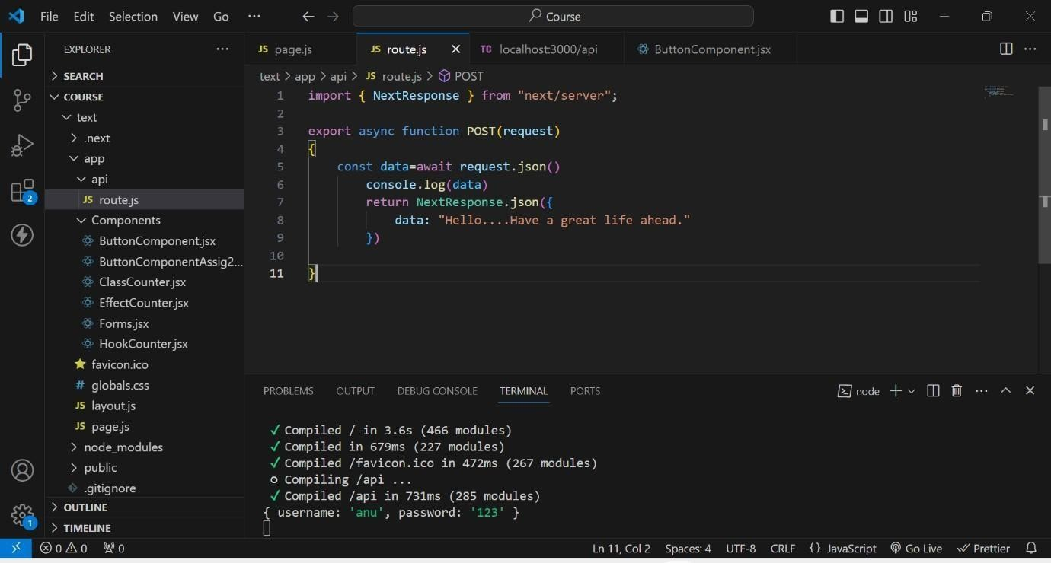

# Rest Output on Thunder Client

**This is the output when we create an API using REST.**

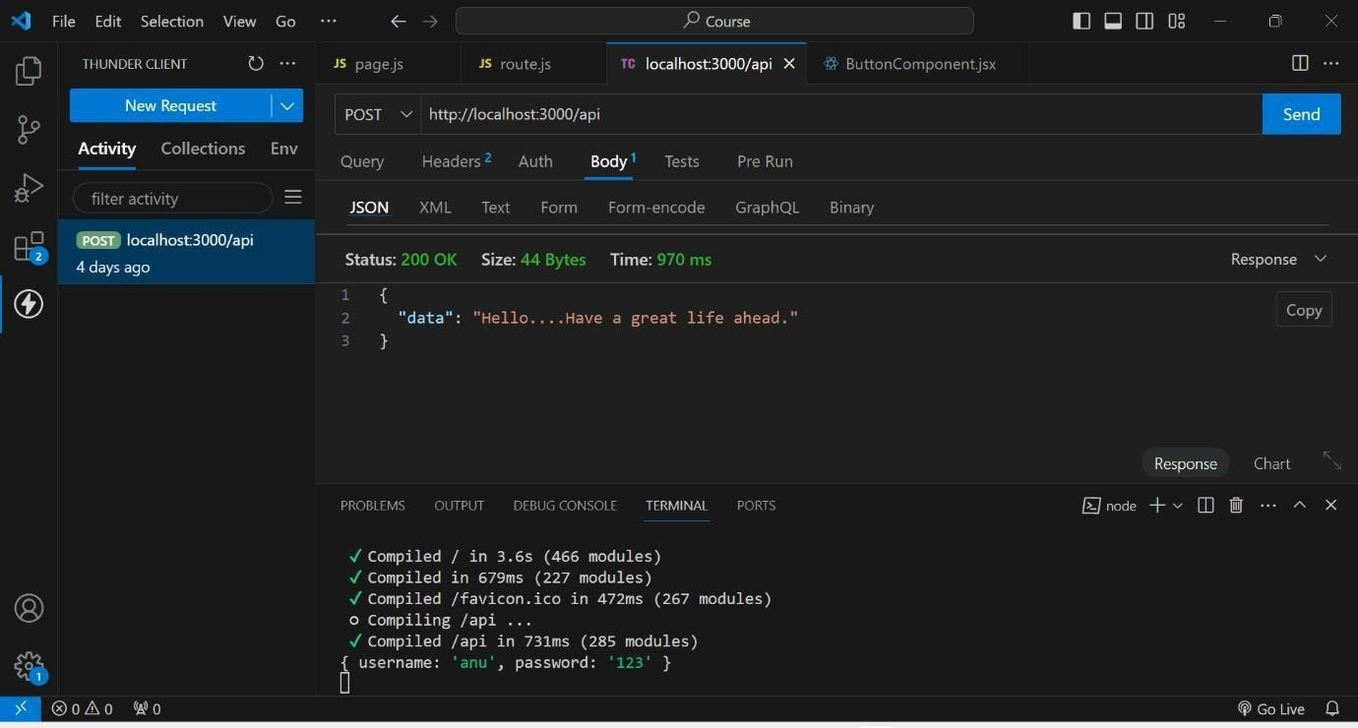

# DataBase Creation

**1st we created a database named test**

**In that test we created a collection named Students**

**And finally by using ADD DATA , we added data of the students like rno, name, age.**

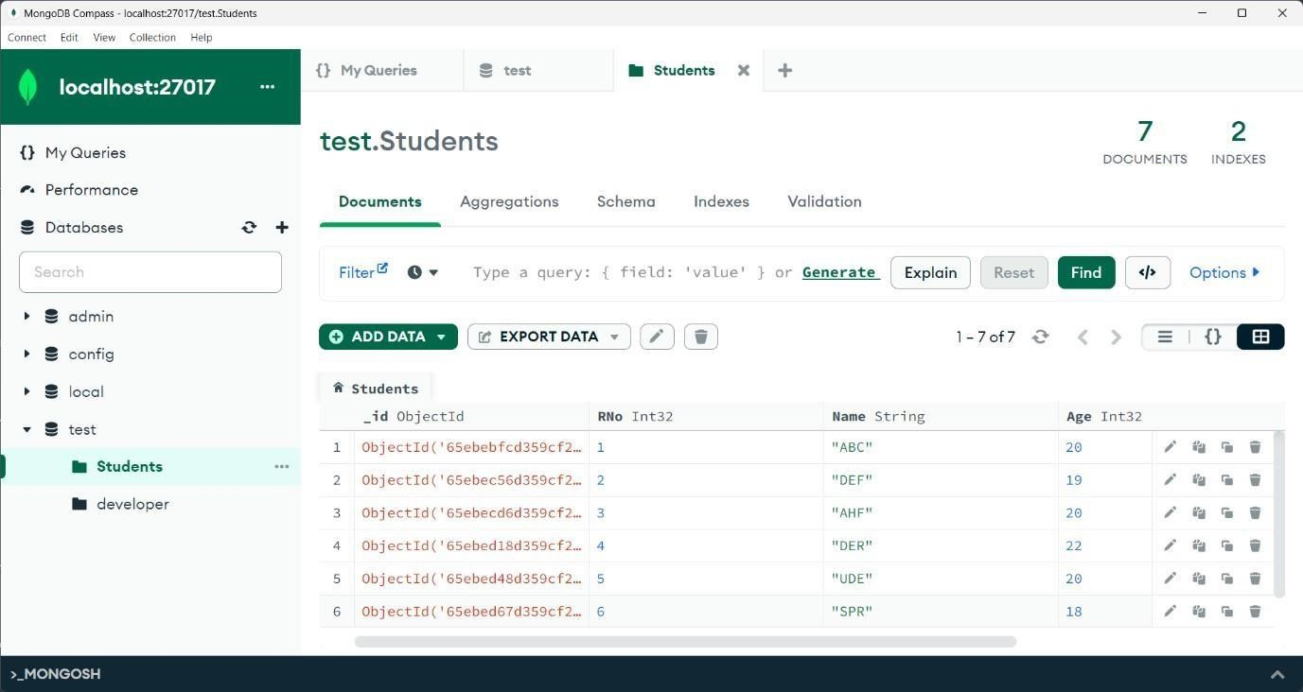

# Indexing Creation

**As rno is the unique attribute through which we identify a student uniquely. So, here I created an index based on Rno. And assigned unique key to it.**

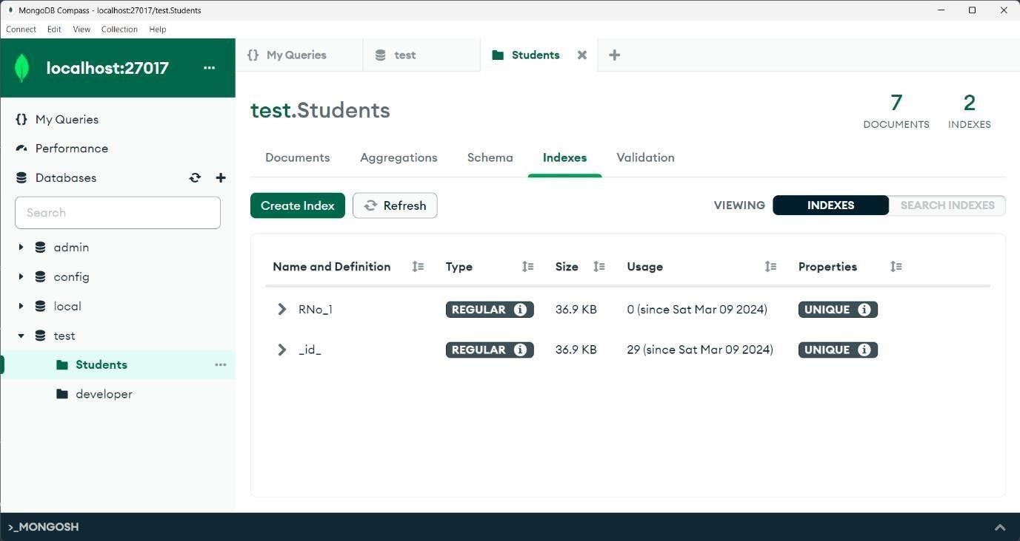

# Indexing usage

**As we gave Rno as unique, if we try to insert a duplicate document that is existed it shows an error like. Duplicate collection.**

